Lionel A. Haydel
February 23, 1899 – May 17, 1962

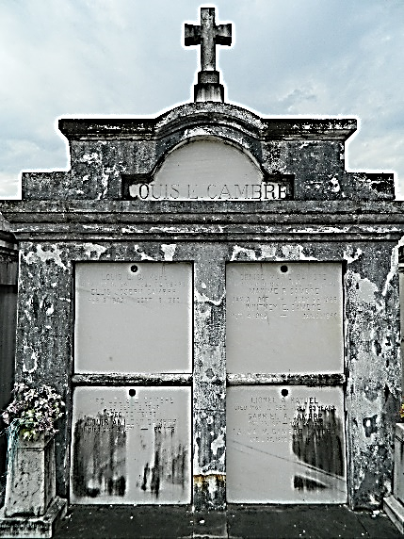

Lionel (Peach) Haydel, a native of Laplace, Louisiana, and a resident of New Orleans for the past 35 years, died at his residence on Thursday, 17 May 1962 at 8:45 a.m. at age 63 years.
He was the husband of Alma Cambre and the son of the late Victorin Haydel and Alida Cassagne. He was the brother of Mrs. Alida Scallon, Mrs. Paul McLauren, Edgar, Nelson, Sidney and James Haydel.
Services were Saturday 19 May 1962 at St Joan of Arc Church, Laplace, with interment in St Peter Cemetery, Reserve, Louisiana.

The Times-Picayune, New Orleans, Louisiana
October 30, 1974, p. 16

